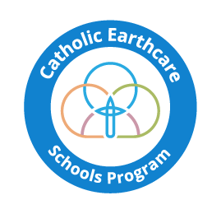
CATHOLIC EARTHCARE SCHOOLS
LEVEL 4 CHECKLIST

The information provided below will be used to assess whether your school is a Level 4 Earthcare School. Provide as much information as possible for your assessment; include audit results (before and after) photos, media articles etc.
Information required | School seeking Level 4 certification | Peer assessing school
School Name
Principal’s Name
Website address
Diocese
Earthcare Contact Name
Best Contact Number (mobile preferred)
*please note; if you are not using another school at the same or higher level than your school for this assessment, ignore the last column.
Which Laudato Si’ Action goals have you actioned?
(please show all goals actioned and audit results)
Laudato Si’ Action goal | Theme/Project | Rate your completion/ success of this goal
E.g. Ecological Economics | Energy reduction installed solar panels | 80%

Describe any audits conducted.
Provide some ‘before and after’ data to show ecological changes that have taken place in your school.
Type of audit | Before data | After data | Relevant Laudato Si’ goal
E.g. Waste audit | 200 kg landfill, 100 kg recycles and 150 kg organic waste | 100 kg land fill, 50 kg recycles and 10 kg organic waste. | Cry of the Earth

Please describe the cultural change your school has gone through.
- How has this journey been documented at your school?

How have you ensured that these ecological changes will be sustained and become a part of the school’s culture?

Describe any networking or collaborative Earthcare projects your school has been involved with?
- Which schools or partner organisations are you working with?
- Will these networking and partnering arrangements continue well into the future?

Can you describe the ‘formation of the heart’ activities in your school which demonstrate that a deep ecological conversion has taken place in students and staff?
- Students

- Staff

- Other

Will the school now move onto Level 5 certification? Yes or No
If yes access the Level 5 Audit Certification Criteria.
Once we receive your self-audit in a PDF format, Catholic Earthcare will assess your report, then send a Level 4 certificate to you to acknowledge your Level 4 certification.
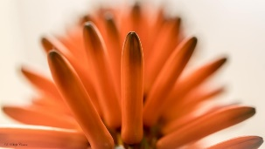

Aloe flower Photo: David Conser

