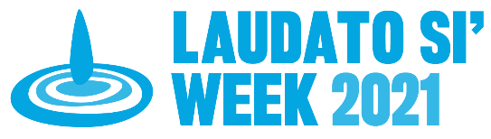
Caring for the Earth
- Living Laudato Si’

“It is time to act”…, the planet is “at the brink” and humanity has to avoid the “path of self-destruction”. Pope Francis, Earth Day 2021.

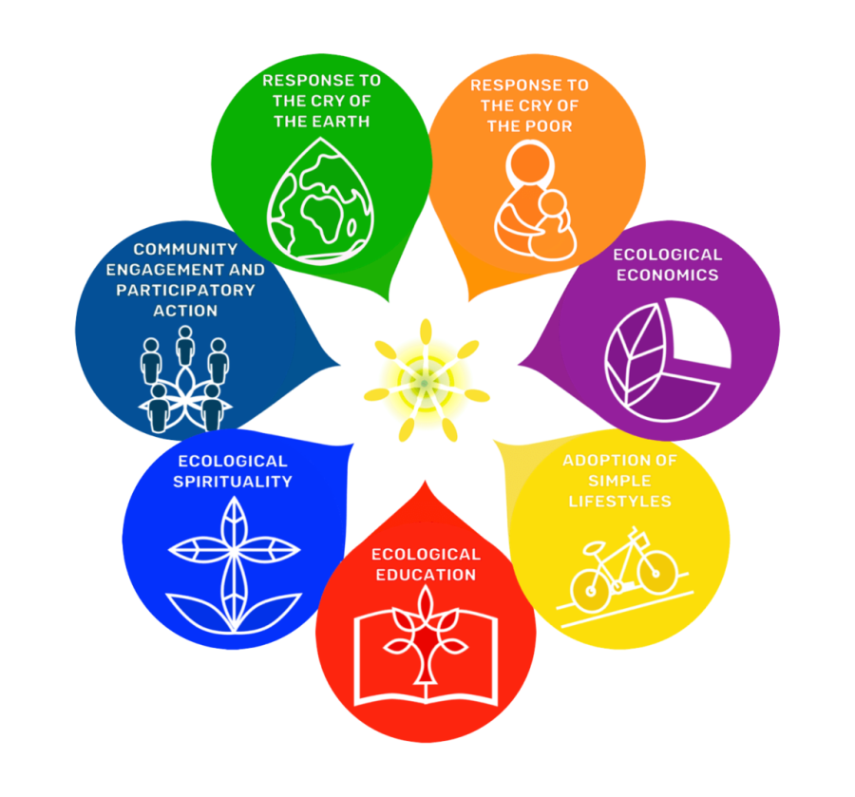Laudato Si’ Goals
1. Am I hearing and responding to the cry of the earth?
- Reducing reliance on fossil fuels (coal, oil, gas).
- Using power from renewable non-polluting sources (solar, wind).
- Minimizing fossil fuel-based road and air travel.
- Reducing plastics and packaging, trying to buy in bulk.

2. Am I hearing and responding to the cry of the poor?
- Making lifestyle changes which will care for the world’s poorest.
- Purchasing goods and using energy which support sustainable, ethical and fair production.

3. Am I considering and acting on ecological economics?
- Moving finances and investments from banks, superannuation and shares that fund fossil fuels or other activity harmful to the planet.
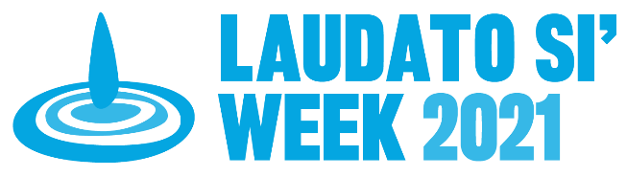
Laudato Si’ Goals
4. How am I faring with adopting a simpler lifestyle?
- Adopting the 5 Rs. Refuse what you don’t need, Reduce what you do need, Recycle, Re-use and Rot (compost)
- Eating less meat, poultry and fish and more plant-based foods.
- Buying locally grown foods and locally made products.
- Growing more trees and plants and my own food.
- Walking cycling, using public transport more often.

5. Am I educating myself and others towards integral ecology to further my awareness and action?
- Learning more about climate change, biodiversity loss and the threat of extinction and teaching others.
- Getting reputable information from independent sources (not those influenced by fossil fuel interests or other vested interests).

6. How am I faring in developing ecological spirituality?
- Focusing on the wonders of the natural world.
- Praising and thanking God for creation.
- Respecting culture and ecological spirituality of indigenous peoples.

7. Am I engaging in and participating in community action for care of creation?
- Supporting public action on climate change and environment.
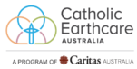
- Calling on political and industry leaders for stronger action on carbon emissions and environmental protections.
Adapted from Laudato Si Week and ARRCC - Living the Change websites

