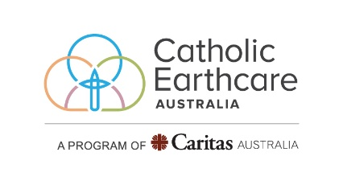
User Guide to Documents and Levels

Level 1 Register with Catholic Earthcare and share the journey so far.

Level 2 Use this self-guided audit to see how your school is currently situated with regards caring for our common home. Once completed submit and receive level 2 certification. You are now ready to undertake the level 3 challenge
Documents include:
▪ Self-assessment tool
▪ Environmental Review Early Years, or Environmental Review Primary, or Environmental Review Secondary
▪ Basic Curriculum audit

Level 3 For schools already doing good things. Create an action plan based on the data you collected during the self-Evaluation. Look at the Self-Evaluation tool to help you understand what is required and work backwards from that.
Documents include:
▪ Self-assessment tool
▪ Environmental Review Early Years, or Environmental Review Primary, or Environmental Review Secondary
▪ Basic curriculum audit
▪ Action Plan
▪ Detailed curriculum audit (optional)
▪ Self-evaluation tool

Level 4 For schools that are quite mature in their processes and programs for Caring for our Common Home. Look at the Peer-validated assessment tool and work backwards to understand what is required.
Documents include:
▪ Self-assessment tool
▪ Environmental Review Early Years, or Environmental Review Primary, or Environmental Review Secondary
▪ Action Plan
▪ Basic curriculum audit
▪ Detailed curriculum audit (optional)
▪ Peer validated assessment tool

Level 5
This Levels will be accessible to successful Level 4 schools
Schools will work with Earthcare staff on a report showcasing Catholic Earthcare Steps to Ecological Dialogue with an emphasis on Step 7 Sustain and Go Forth and Step 8 Animate Others

